**Marketing and communicating the case for change**

Changing organisations naturally involves changing established meaning systems; thus, marketing and communicating the case for change is often a reframing exercise. The change manager must be sensitive to internal marketing techniques as a key part of their toolkit. The change project must have a brand identity and associated marketing vehicles. The range of marketing vehicles that the change manager can adopt as part of the framing of the change project as a central aspect of the case for change could include:

* Brand identity for the change project
* Branded screen savers
* Branded posters
* Change slogans
* Branded mouse mats
* Change practitioner recognition schemes
* Communications schedules
* Storyboards
* Videos
* Internal plays and theatre events
* Change conferences

Thus, it is important to involve the internal marketing team in the collaborative design of a marketing programme to support the overall change project. In some situations, depending on the scale of the change project the change manager may also engage with an external public relations firm to support the communications plan, schedule, and marketing plan.

A productive example of a large-scale organisation using marketing, and specifically branding, to advance a change project was The City of Glasgow back in the late 1980s and mid-1990s. The City of Glasgow embarked on a significant economic and cultural change project to rejuvenate the city which involved reframing the city throughout the world. This involved dropping the old frame of a city plagued with crime and poverty to a new frame which involved a highly innovative, friendly, and welcoming city that was open for business. Central to the significant change project was the introduction of a brand slogan and a brand logo. The slogan was ‘Glasgow’s Miles Better’ and the logo was a Mr Smiley metaphor.

The metaphor of a smiley character enabled those targeted to place their own meaning and perspective, e.g., a city that is full of friendly people, a co-operative city, a can-do city, a city that is welcoming and fun and one that is a great host. This campaign was incredibly successful, and the visual metaphor was central to the success and complete transformation of the City of Glasgow.

Today we all know the importance of social media as a form of communication and influence. Change leaders should integrate a social media campaign as a key element of their marketing and communications programme for the change project. Creating a change team Instagram or WhatsApp group is a productive way of building change team community and communicating team and individual progress in real-time. Often the marketing plan and the communications plan for a change project are integrated. The communications plan would typically include communication tools such as:

* Newsletters
* Staff magazines
* Podcasts
* Video messages
* Briefing notes
* Conversational circles
* Coffee mornings
* Presentations
* Roadshows

We should not always assume that managers are effective communicators and so a short and effective training course with an expert in communication techniques including face to face interactions, chairing meetings and delivering presentations would be advisable.

Albert Mehrabian, a scholar interested in communication, conducted research which he published in 1967. He generated a model of communication which centred around events in which stakeholders involved in communication loops had an emotional investment. Change management events would fit this criterion. He discovered that only 7% of meaning interpreted on the part of the receiver of a message related to the choice of words. Rather 55% was based upon interpretation of body language and 38% voice tone.

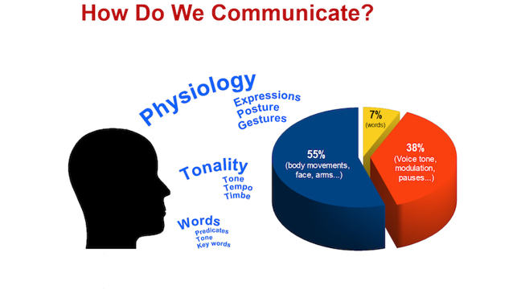

We also know that active listening skills are important change management skills. When we communicate change messages, we should not adopt a one-dimensional flow, a monologue, we should encourage a two-dimensional communication flow that encourages exchanges of ideas between all stakeholders that the change manager/leader is engaging with. This means that stakeholders need to know that they are being heard, that they are being listened to, and that they are valued. The way in which we set up rooms to host communication events is also important. We know that room layout influences the psychology of change participants and either enables or blocks the motivation to express oneself.

**Key Lessons**

Throughout the change management literature, the role of internal marketing to help frame and advance the case for change is underdeveloped. However, its utility as a change management tool is gaining attention. The marketing programme should ideally be under the control of the change manager. The marketing plan should be adequately resourced and again it should be completed in a highly focused workshop and should involve the contribution of senior management. Branding is acutely important, the change programme needs a catchy brand identity and a supporting logo or strapline, as we saw above with the Glasgow’s Miles Better campaign. The marketing plan must be creative, visual, and personally meaningful for change participants. It should evoke positive emotions and frame the case for change in a very convincing way as well as framing the end state, the future scenario that everyone is working towards.

**Exercise**

Please review the Albert Mehrabian model and describe the implications for change leaders engaged in stakeholder presentations. How would you attend to the delivery of your presentation so that you built in his model of communication as an integral part of your delivery approach? Post your responses so that others can see them. Take some time to read other people’s responses and compare them to your own.